**PROJECT TITLE**: CREATE BRAND NAME, BRAND LOGO AND BRAND MAIL IN CANVA

ABSTRACT:

In today's competitive business landscape, establishing a strong brand identity is essential for success. This aims to demonstrate the process of crafting a unique brand name and a compelling logo using the user-friendly design platform, Canva. The project will begin by discussing the significance of a well-defined brand identity and the crucial role it plays in creating a lasting impression on consumers. It will emphasize the need for a brand name and logo that reflect the company's values, mission, and personality. The primary focus of the project will be on the practical aspects of utilizing Canva, a popular online design tool, to create a brand name and logo. It will include step-by-step instructions on how to access Canva, select design templates, customize fonts, colours, and icons, and design a logo that resonates with the intended brand image.

INTRODUCTION TO DIGITAL MARKETING:

Digital marketing is a dynamic and rapidly evolving field that has revolutionized the way businesses reach and engage with their target audiences. It encompasses a wide range of online strategies and tactics aimed at promoting products, services, or brands using digital channels and technologies. In this introduction to digital marketing, we will explore the fundamental concepts, components, and key strategies that underpin this critical aspect of modern business.

KEY COMPONENTS OF DIGITAL MARKETING:

1.Online Presence: At the core of digital marketing is establishing a strong online presence. This includes having a website and profiles on social media platforms. Your website serves as the digital storefront where potential customers can learn about your offerings.

2. Content Marketing: Content is king in the digital world. Creating valuable and relevant content such as blog posts, articles, videos, and infographics not only educates and engages your audience but also improves your website's search engine visibility.

3. Search Engine Optimization (SEO): SEO is the practice of optimizing your website to rank higher in search engine results pages (SERPs). By using relevant keywords and improving your site's structure, you can increase organic (non-paid) traffic.

4. Social Media Marketing: Leveraging platforms like Facebook, Twitter, Instagram, and LinkedIn, social media marketing allows you to interact with your audience, share content, and run targeted advertising campaigns.

5. Email Marketing: Email marketing is an effective way to nurture leads, engage with customers, and promote products or services directly to a subscriber list.

6. Pay-Per-Click (PPC) Advertising: PPC advertising is a model where advertisers pay a fee each time their ad is clicked. It's often used in search engine marketing and social media advertising to drive traffic and conversions.

7. Online Advertising: This includes display ads, video ads, and other forms of advertising on various online platforms.

8. Affiliate Marketing: Businesses partner with affiliates who promote their products or services, and in return, they earn a commission for each sale or lead generated.

9. Analytics and Data Analysis: Digital marketing relies heavily on data. Tools like Google Analytics provide insights into website traffic, visitor behavior, and campaign performance, enabling data-driven decision-making.

10. Mobile Marketing: As more users access the internet through mobile devices, mobile marketing focuses on optimizing content and ads for mobile users.

BENEFITS OF DIGITAL MARKETING:

1. Global Reach: Digital marketing allows businesses to reach a global audience, breaking down geographical barriers.

2. Cost-Effective: Many digital marketing strategies are cost-effective compared to traditional advertising methods.

3. Targeted Advertising: Digital marketing provides precise targeting options, ensuring your message reaches the right audience.

4. Measurable Results: It's easy to track and measure the performance of digital marketing campaigns, allowing for adjustments and improvements.

5. Interactivity: Digital marketing encourages two-way communication with customers, fostering engagement and brand loyalty.

6. Real Time Engagement: Businesses can engage with their audience in real-time, addressing concerns and inquiries promptly.

7. Flexibility: Digital marketing campaigns can be adjusted quickly in response to changing market conditions.

IMPORTANCE OF DIGITAL MARKETING:

Any type of marketing can help your business thrive. However, digital marketing has become increasingly important because of how accessible digital channels are. In fact, there were 5 billion internet users globally in April 2022 alone.From social media to text messages, there are many ways to use digital marketing tactics in order to communicate with your target audience. Additionally, digital marketing has minimal upfront costs, making it a cost-effective marketing technique for small businesses.

1.Wide Reach: Digital marketing allows businesses to reach a global audience. Through various online channels such as websites, social media, email, and search engines, you can connect with people from all over the world.

2.Cost-Effective: Compared to traditional marketing methods like TV or print advertising, digital marketing is often more cost-effective. It allows businesses with limited budgets to compete with larger ones.

3.Measurable Results: Digital marketing provides tools and metrics to measure the effectiveness of your campaigns. You can track the number of website visitors, conversion rates, email open rates, and more. This data enables you to make data-driven decisions and optimize your marketing efforts.

4.Targeted Advertising: With digital marketing, you can target specific demographics, interests, and behaviors. This precision in targeting ensures that your messages reach the most relevant audience, increasing the chances of conversion.

5.Immediate Feedback: Digital marketing channels provide almost immediate feedback. You can see how your audience is responding to your campaigns and make adjustments in real-time. This agility is a significant advantage over traditional marketing, where changes can be slow and costly.

6.Brand Awareness and Loyalty: Consistent digital marketing efforts can help build and strengthen brand awareness and loyalty. Engaging with your audience on social media and through email can foster a sense of community and trust.

BRAND NAME, LOGO AND MAIL:

Creating a cohesive and professional brand identity involves not only the brand name and logo but also the design and communication of branded materials, including business emails. Here's how they all work together:

1.Brand Name: Your brand name is the fundamental element of your brand identity. It's the name by which your business is known and recognized. It should be unique, memorable, and reflect your brand's values, mission, and personality. A strong brand name is the foundation upon which your entire brand identity is built.

2.Logo: The logo is the visual representation of your brand. It's a graphic or symbol that often includes your brand name in a stylized or unique font. The logo should be designed to be visually appealing, memorable, and convey the essence of your brand. It's typically used on all your marketing materials, products, and digital assets.

3.Business Email: Your business email is a crucial part of your brand identity, as it's a direct communication channel with customers, partners, and stakeholders. It's essential to use a professional and branded email address that includes your brand name. For example, if your brand name is "ABC Solutions," your business email could be something like "john@abcsolutions.com." This not only looks more professional but also reinforces your brand name in every email you send.

Also, you can customize the email signature with your logo, brand colors, and other branding elements to ensure consistency and professionalism in your email communications. Here's how these three elements work together:

1.Consistency: The brand name is a constant that ties everything together. Whether people see your logo, visit your website, or receive an email from you, the consistent use of your brand name reinforces your brand's identity.

2.Recognition: Your logo and brand name should be designed to work harmoniously. When people see your logo, they should be able to associate it with your brand name instantly. This consistency helps in brand recognition and recall.

3.Professionalism: Using your brand name and logo in your business emails adds a professional touch to your communication. It shows that you pay attention to detail and take your brand seriously, which can instill confidence in your recipients.

4.Branded Experience: When your brand name, logo, and email communications are aligned, it creates a seamless and branded experience for your audience. It makes your brand more memorable and recognizable.

KEY COMPONENTS OF BRAND NAME, LOGO AND MAIL:

The brand name, logo, and business email are integral components of your brand identity, and they should work together to create a cohesive and professional image for your business. Consistency in the use of your brand elements across all touchpoints is key to building a strong and memorable brand. Developing a brand name, logo, and business email involves a creative and strategic process. Here's a step-by-step guide on how to approach each of these components:

1. Developing a Brand Name:

Define Your Brand: Start by understanding your brand's values, mission, and personality. What do you want your brand to convey to your target audience? Define your unique selling points and what sets you apart from competitors.

Brainstorm: Gather a team or individuals for a brainstorming session. Generate a list of potential brand names that align with your brand's identity and messaging.

Check Availability: Ensure that the brand name you choose is unique and not already trademarked by another company in your industry. Search domain name availability as well if you plan to have an online presence.

Test and Get Feedback: Share your potential brand names with a focus group or trusted individuals to get their feedback. Their input can help you make an informed decision.

Select the Name: After careful consideration and legal checks, choose a brand name that resonates with your brand's identity and values.

2. Designing a Logo:

Hire a Professional Designer: It's highly recommended to work with a professional graphic designer or design agency. They have the skills and experience to create a unique and effective logo.

Provide a Creative Brief: Share your brand's mission, values, target audience, and any specific ideas you have in mind with the designer. A well-defined creative brief helps the designer understand your brand better.

Sketch and Concept Development: The designer will typically start with sketching concepts and then move on to digital design. They may provide you with several initial design options.

Feedback and Iteration: Review the initial designs and provide feedback. Discuss what you like and dislike about each concept. Work collaboratively with the designer to refine the design.

Color and Typography: Select appropriate colors and typography that align with your brand's identity. Ensure that the chosen colors are versatile and work well in various applications.

Finalize the Logo: Once you are satisfied with the design, the designer will provide you with the final logo files in various formats (e.g., PNG, JPEG, vector formats) for different use cases.

3. Creating a Business Email:

Choose a Domain Name: If you haven't already, select a domain name that matches your brand name or is closely related to it.

Select an Email Hosting Service: Sign up for a professional email hosting service. Popular options include Google Workspace (formerly G Suite), Microsoft 365, or other business email providers.

Create Branded Email Addresses: Set up branded email addresses using your domain name. For example, if your brand name is "ABC Solutions," you can have email addresses like "info@abcsolutions.com" or "contact@abcsolutions.com."

Design Email Signatures: Create consistent and professional email signatures that include your logo, contact information, and links to your website and social media profiles.

Configure Email Clients: Set up email clients or apps to access your branded email accounts.

Train Your Team: If you have a team, provide training on how to use the business email system effectively and maintain professionalism in email communication.

Remember that these processes may take time and may involve some cost, especially when hiring professionals for logo design and email hosting. However, investing in a strong brand name, logo, and professional email can significantly impact your brand's image and long-term success.

PROJECT IMPLEMENTATION:

Let us create a brand name, brand logo and brand mail in canva app.

BRAND NAME: Shine Thrifts

BRAND LOGO:



BRAND MAIL: [shinethrifts@gmail.com](mailto:shinethrifts@gmail.com)

CATEGORY: Clothing brand

TARGET AUDIENCE: For all dresses and thrifting lovers

TARGET LOCATION: All over India

First of all, define your brand and choose a brand name accordingly for developing your brand. We have chosen a thrifting brand and named it as ”Shine thrifting”. Thrifting refers to the practice of buying second-hand or used items, typically clothing, furniture, household goods, and other consumer products, from thrift stores, consignment shops, garage sales, flea markets, or online platforms that facilitate the resale of pre-owned items. Thrifting has gained popularity for several reasons such as cost saving, environmental benefits, unique finds, supporting charities, etc

Secondly, Create a Brand logo for your brand. We have mentioned the steps involved in it.

STEP 1: Log in/ sign up in Canva app

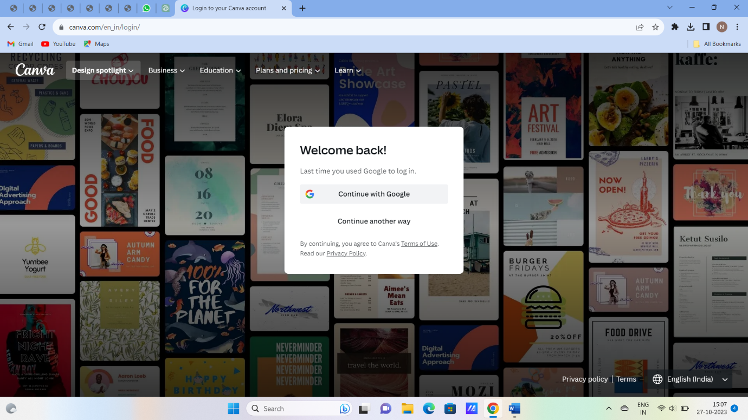

STEP 2: Search for logo template

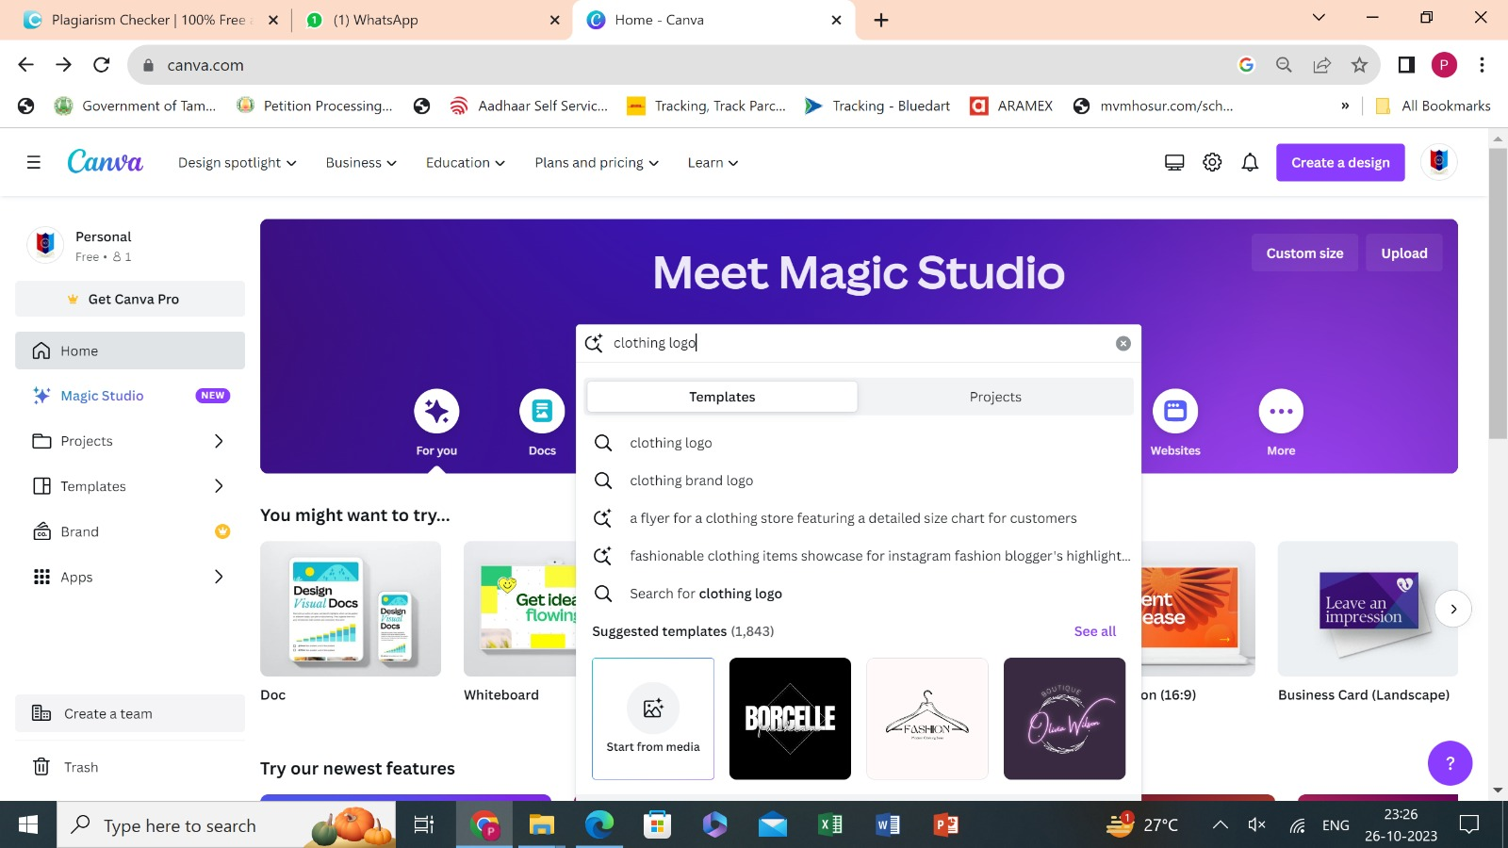

STEP 3: Select logo which is appropriate for your brand

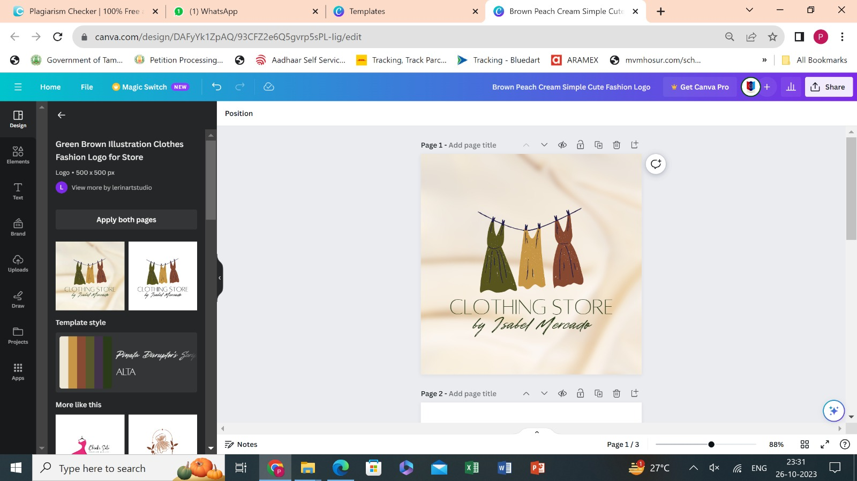

STEP 4: Edit the brand name in the template

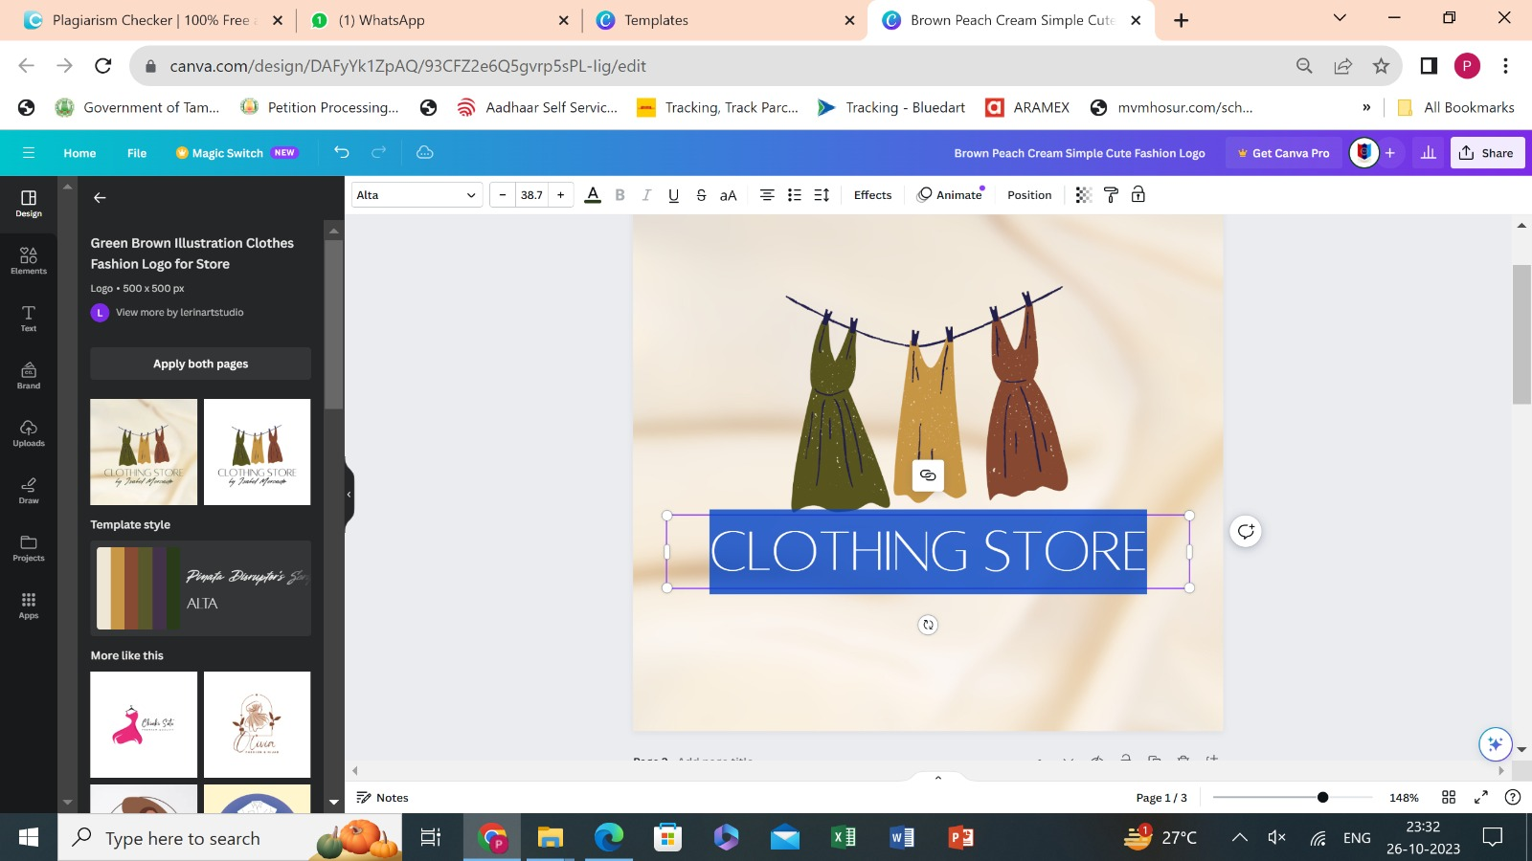

STEP 5: Enter your brand name in the template

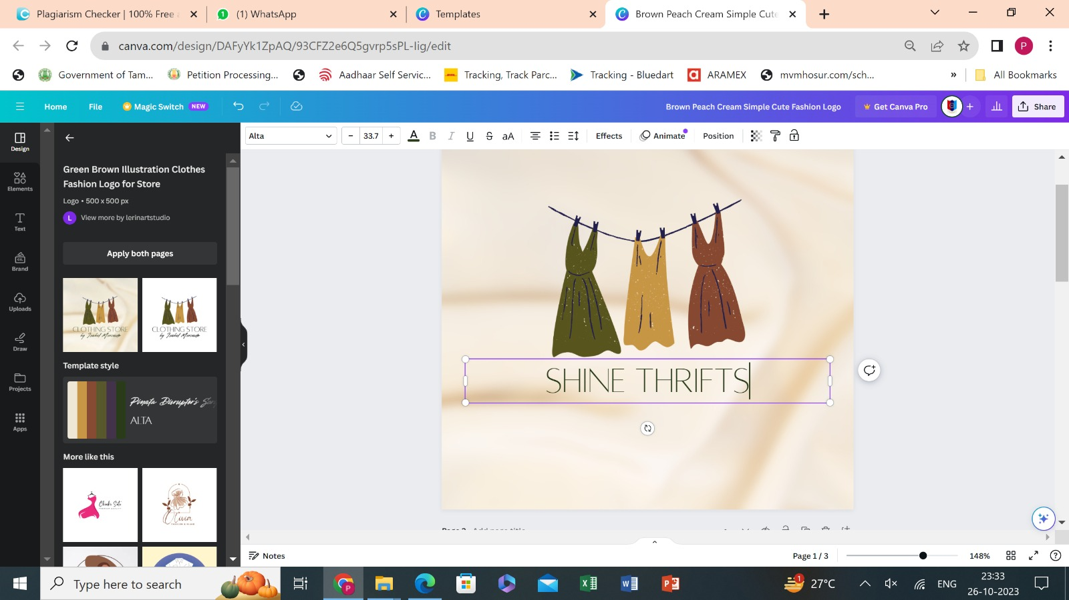

STEP 6: Finalize your logo and download it

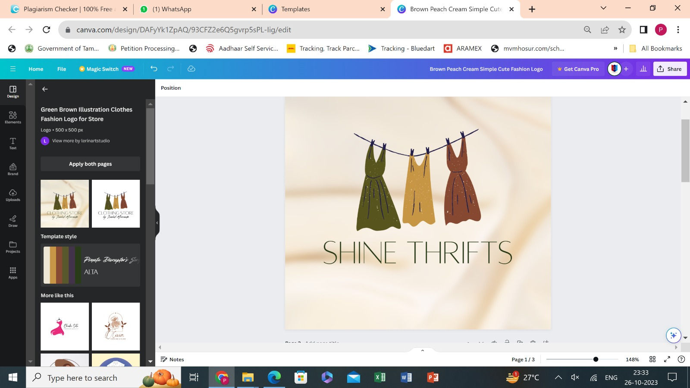

Finally, Create a mail id for your brand and here we have mentioned the steps involved in creating mail id using gmail for your brand

Step 1: Create a name for your mail using your brand name

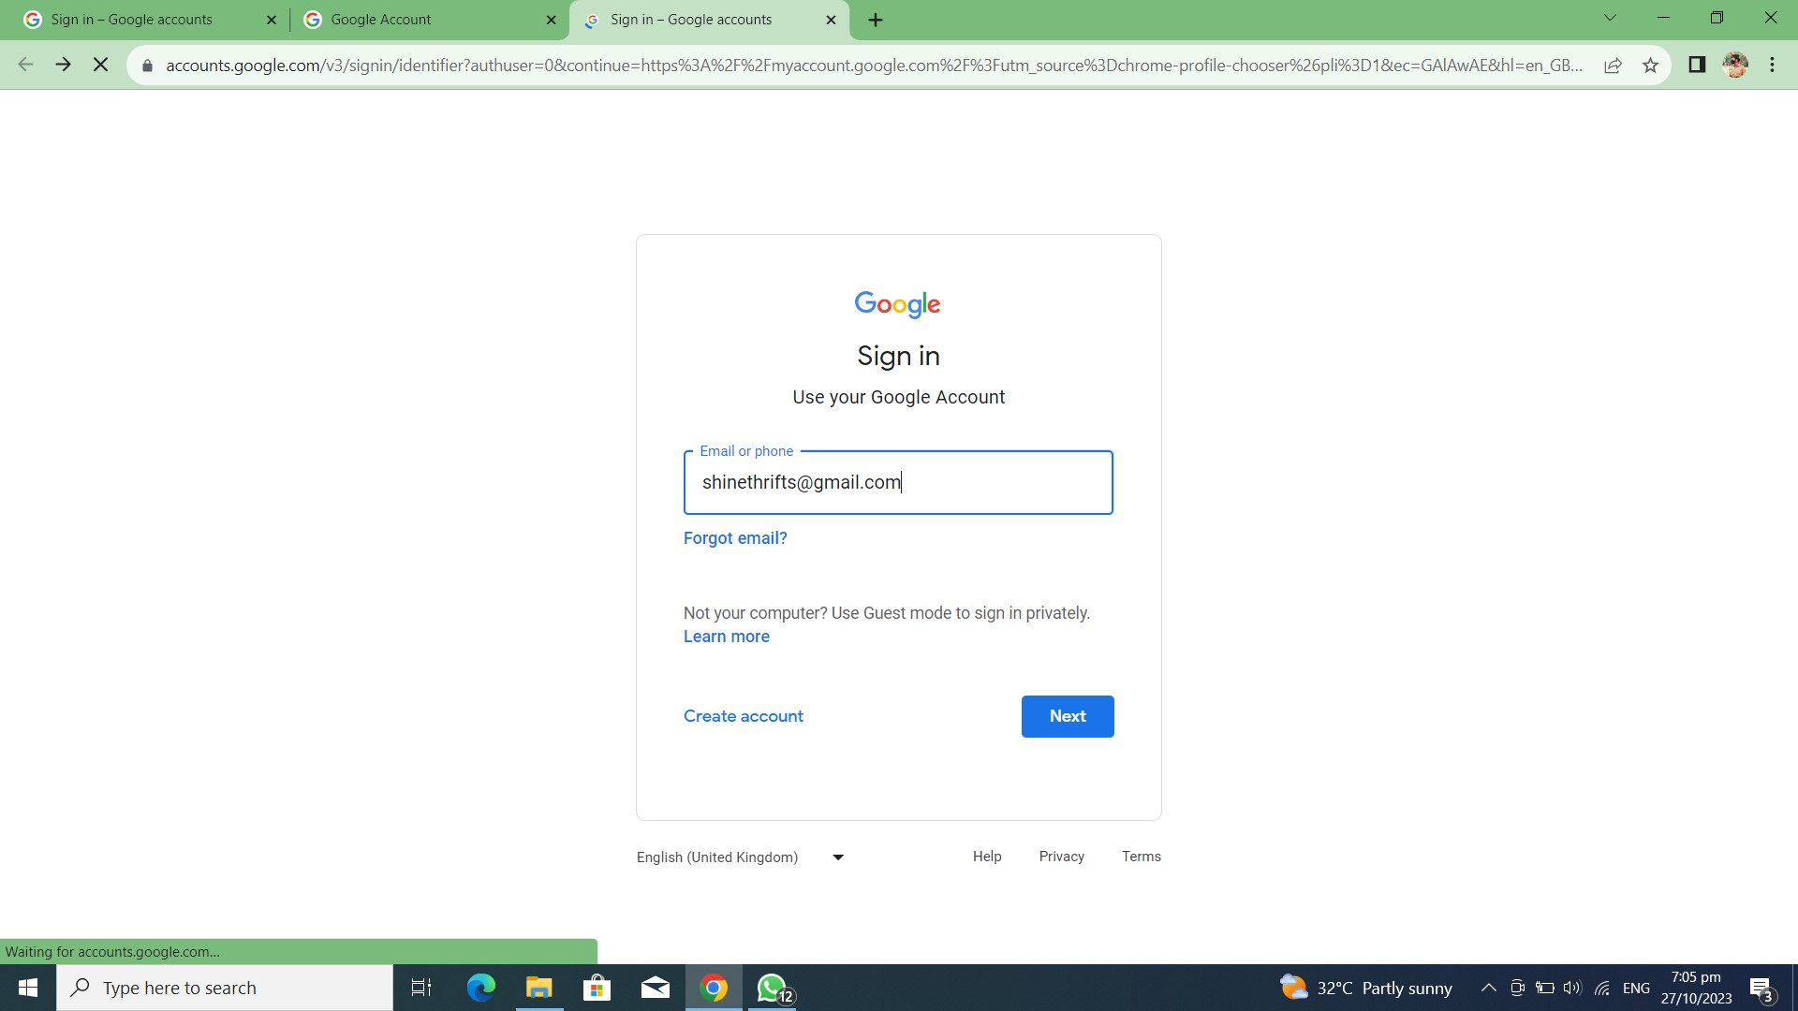

Step 2: Make a password for your mail account and keep it confidential

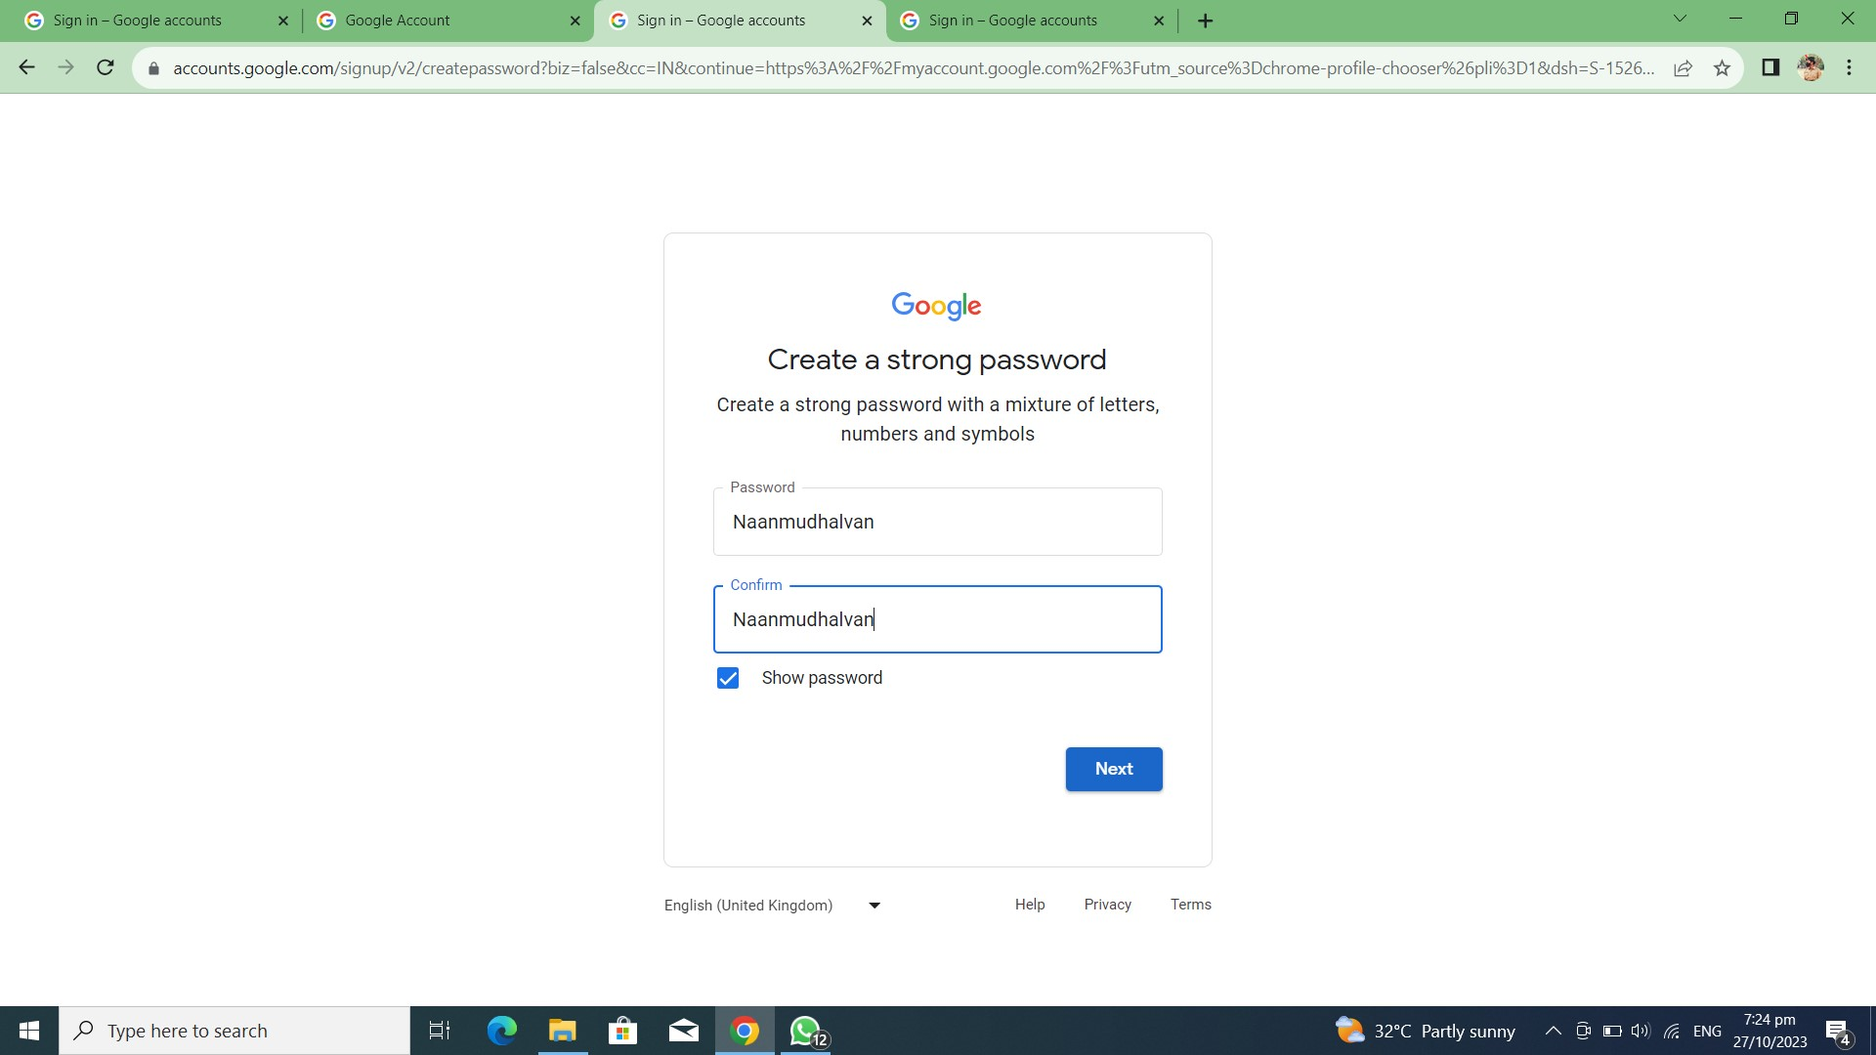

Step 3: Select the appropriate mail id name for your brand

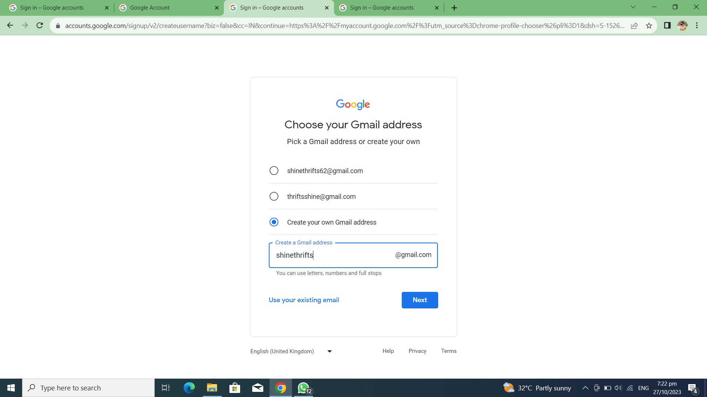

Step 4: Read and agree all the conditions

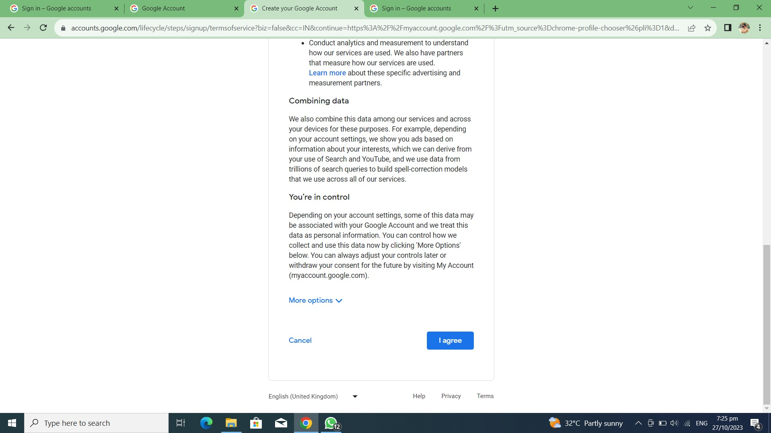

Step 5: Your mail account is created

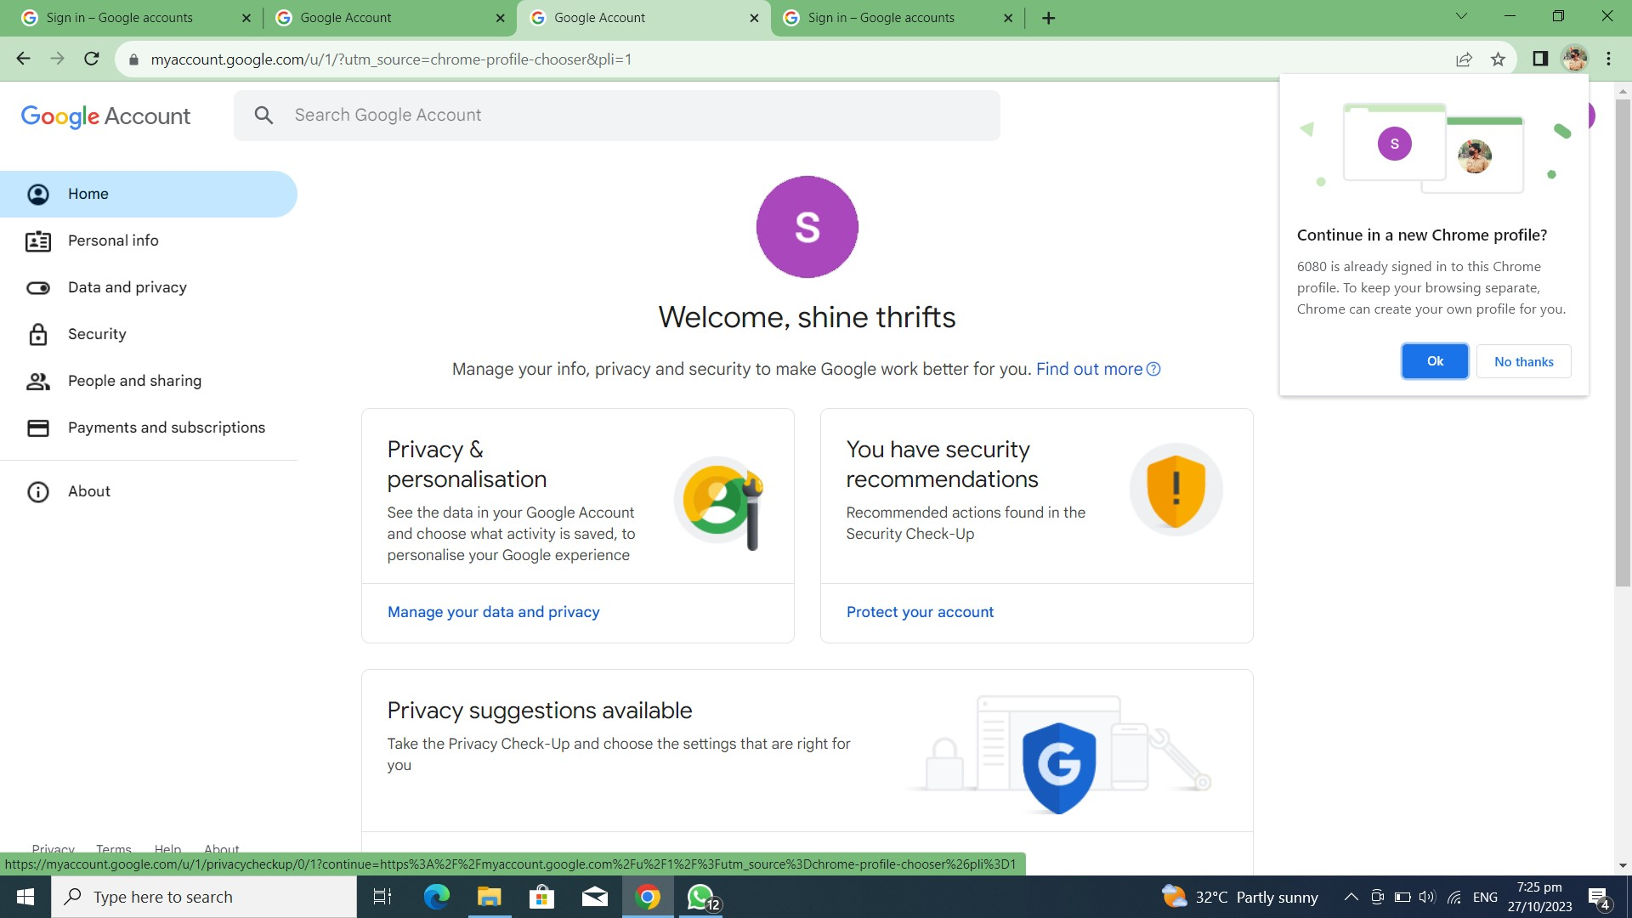

CONCLUSION:

Our project in digital marketing, which involved the creation of a brand logo and professional business email using Canva, has been a successful endeavor. Throughout this project, we've harnessed the power of digital tools to develop key elements of our brand identity, and these accomplishments are worth celebrating. The creation of our brand logo was a collaborative effort that allowed us to visually represent our brand in a unique and memorable way. Canva, with its user-friendly design tools, enabled us to translate our brand's values and personality into a visually appealing logo that will serve as the face of our business.

This project showcases the power of digital marketing tools like Canva to create essential brand assets and the importance of these assets in building a successful brand in today's digital age. We're excited to embark on the next phase of our digital marketing journey, armed with a brand logo and email that will help us stand out and make a lasting impression in the digital space.